|  |  |  |
| --- | --- | --- |
| **Experiment No. : 3** | **TODO LIST APPLICATION** | **Date: 7/4/22** |

**AIM:** To design a To-do List Application.

**Theory:** This whole project has only one concept, that to record your daily task and to-do lists.

will add a task and also edit it.

You have to provide the task description. The whole project has a simple-looking UI design.

**1.** We need to define the layout of our views. In particular, we want to add Button, a EditText and a ListView to our Activity.

**2.** Add the string resources that provide the hint text and content description

included in step 1 to the strings.xml resource stored in the project’s res/values folder.

**3.** We need to create a list of todo items to display and an adapter to display them in our ListView within the Activity java file

**4.** Add an android:onClick handler to our layout XML file. Define an ArrayList of Strings to store each to-do list item. You can bind a ListView to an ArrayList using an ArrayAdapter. Create a new ArrayAdapter instance to bind the to-do item array to the ListView.

**5.** Add an onKeyListener to the EditText that listens for either a “D-pad center button” click or the Enter key being pressed. Either of these actions should add the contents of the EditText to the to-do list array created in step 4, and notify the ArrayAdapter of the change. Finally, clear the EditText to prepare for the next item.

**6.** Run the application.

**Layout Code:**

<?xml version="1.0" encoding="utf-8"?>

<LinearLayout xmlns:android="http://schemas.android.com/apk/res/android"

xmlns:app="http://schemas.android.com/apk/res-auto"

xmlns:tools="http://schemas.android.com/tools"

android:orientation="vertical"

android:layout_width="match_parent"

android:layout_height="match_parent"

tools:context=".MainActivity">

<EditText

android:layout_width="match_parent"

android:layout_height="wrap_content"

android:id="@+id/editText"

android:hint="@string/addItemHint"

android:contentDescription="@string/addItemDescription"

/>

<ListView

android:layout_width="match_parent"

android:layout_height="wrap_content"

android:id="@+id/listView"

/>

</LinearLayout>

**Layout Design:**

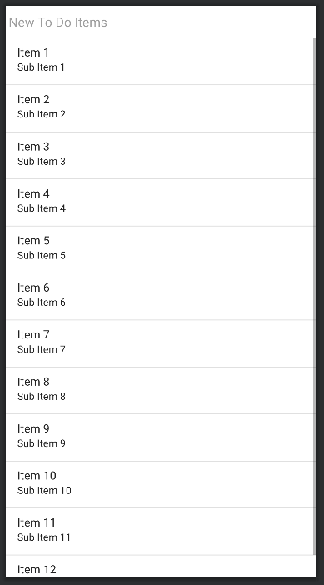

**Strings.xml Code:**

<?xml version="1.0" encoding="utf-8"?>

<resources>

<string name="app_name">ToDo List</string>

<string name="addItemHint">New To Do Items</string>

<string name="addItemDescription">Add New To Do List</string>

</resources>

**Main Java Code:**

package com.ramanand.todolist;

import androidx.appcompat.app.AppCompatActivity;

import android.os.Bundle;

import android.view.KeyEvent;

import android.view.View;

import android.widget.ArrayAdapter;

import android.widget.EditText;

import android.widget.ListView;

import java.util.ArrayList;

public class MainActivity extends AppCompatActivity {

@Override

protected void onCreate(Bundle savedInstanceState) {

super.onCreate(savedInstanceState);

setContentView(R.layout.activity_main);

ListView listView = (ListView) findViewById(R.id.listView);

final EditText editText = (EditText) findViewById(R.id.editText);

final ArrayList<String> todoItems = new ArrayList<String>();

final ArrayAdapter<String> s;

s = new ArrayAdapter<String>(this, android.R.layout.simple_list_item_1, todoItems);

listView.setAdapter(s);

editText.setOnKeyListener(new View.OnKeyListener(){

public boolean onKey(View v, int keyCode, KeyEvent event){

if(event.getAction() == KeyEvent.ACTION_DOWN)

if ((keyCode == KeyEvent.KEYCODE_DPAD_CENTER) ||

(keyCode == KeyEvent.KEYCODE_ENTER)){

todoItems.add(0, editText.getText().toString());

s.notifyDataSetChanged();

editText.setText("");

return true;

}

return false;

}

});

}

}

**Output:**

|  |  |  |
| --- | --- | --- |
| Agnel Institute of Technology & Design  Assagao, Goa.  Department of ECE | | |
| Programming | (2) |  |
| Execution & Result | (3) |  |
| Neatness | (2) |  |
| Viva | (3) |  |
| Total | (10) |  |
| Faculty In-charge sign |  |  |

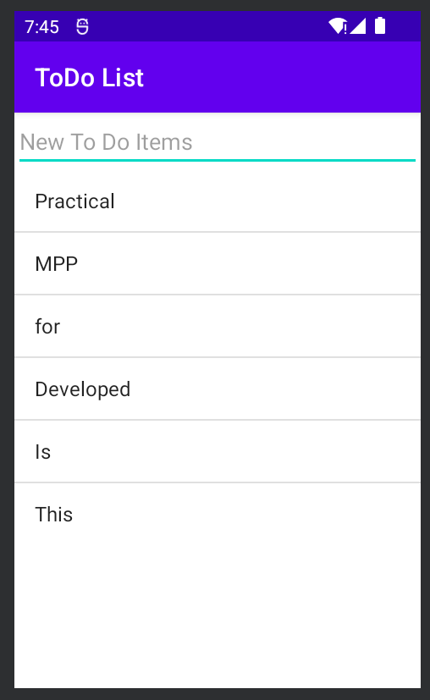

**Conclusion:** The To-do list Application in Android studio was successfully implemented and tested.